- Identify the mood of the passage:
How is the author making me (the reader) understand how he feels? What words is he using to create a mood? The author’s mood makes me (the reader) understand what the author is feeling. Identify 3 different words or phrases.

- Identify the author’s tone:
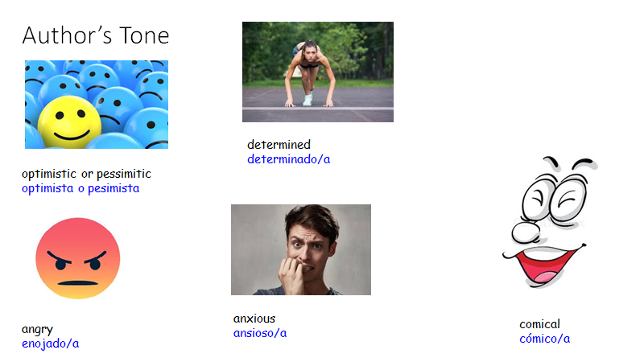
What do you (the reader) think the author’s feels about what he is writing?

Words or phrases the author uses: | What is the author’s tone? What mood is he expressing?
tiny bedroom | Example: (with sentence stems)  The author uses the word tiny to make the reader understand that …Chino is worried about not having enough space for the baby.  The author’s tone is anxious.

