Integrated Content & ENL Unit Planner

Whether you’re using an existing unit from a curriculum or planning on your own, use this unit planner to sufficiently develop students’ oral language to launch them into reading and writing. Make any changes necessary, in terms of number of weeks, focus on reading vs. writing, and activities to best fit your needs.

Suggested timeline:

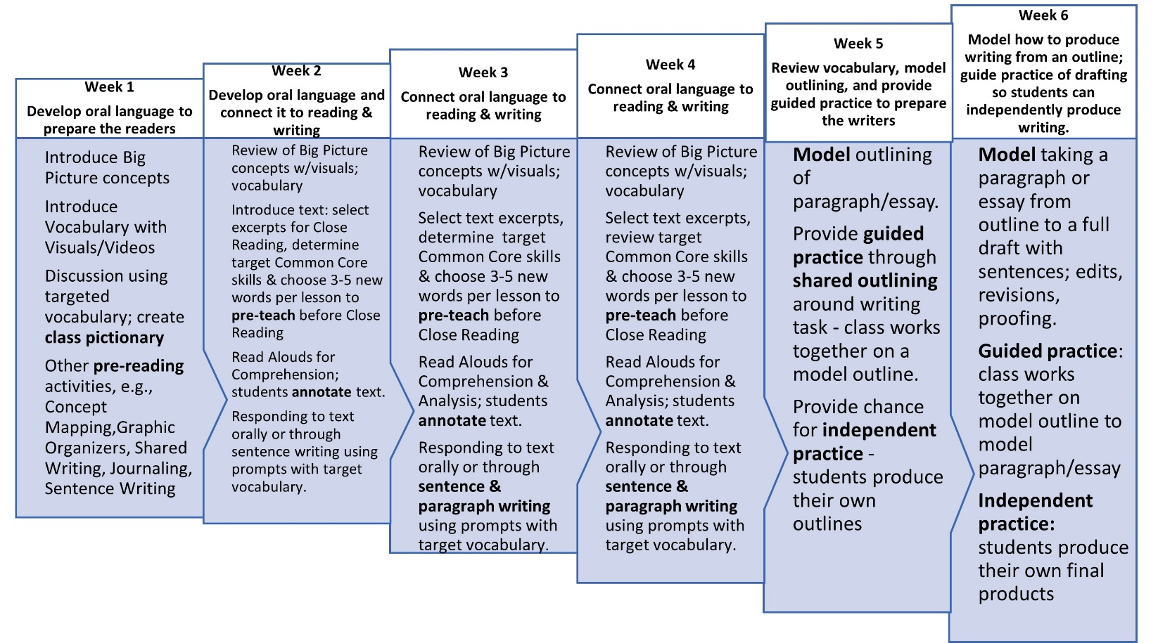

Length of unit (weeks):

Central text(s):

MAJOR CONCEPTS students need in order to access their background knowledge and build schema around this text
(This is what you will focus on and develop target vocabulary in Week 1)

Main Content Objectives of the unit:

End of Unit Assessment:
Linguistic Objectives:  Students will be able to (choose all or one from the following, add to, and/or modify according to your needs):  develop speaking fluency and demonstrate comprehension/analysis of visual/text by orally responding using target vocabulary in complete sentences (with the help of sentence stems or frames if necessary).  Alternatively/additionally: students can respond in Home Language with a partner/group and try translating some or all of their response into oral English.  Newcomers can point, match, and sort pictures and words and maintain pictionary with translations.  develop reading fluency by listening to text read aloud by fluent reader and chorally (or in call and response) reading sentences or excerpts out loud with correct prounciation and intonation. Students need to practice reading aloud the same sentence or excerpt multiple times.  demonstrate comprehension/analysis of text by listening during a Read Aloud, tracking the text with a pencil or finger, and orally summarizing (Who? What? Where? When? How? Why?) the passage in English and/or the Home Language. Students may need to review passage 2-3 times for initial comprehension.  develop academic vocabulary additionally through  - integrated phonics/morphology instruction  demostrate writing ability through sentence writing, paragraph and essay outlining, and producing a finished writing product. | Target Vocabulary for Week 1:  Speaking/Writing prompts for Week 1:
What PRE-READING ACTIVITIES are you going to use over the course of Week 1 to build schema and background knowledge?  Options:  See Think Wonder  Concept sort w/pictures  Student-created picture pictionary (should be used as a reference throughout the unit)  Student-created word wall  Short videos w/graphic organizer work  Concept map w/pictures  Map work (students post or pin things to a map, e.g., students locate the southern U.S. on the map by pinning pictures of where they think the bayou is. Focus question: WHY are bayous located in the south, and not New York?  Word identification scramble: Students work in groups to match vocabulary words to a picture (each group has about 10 words with pictures) – can be timed or not.  Role play: Students work together to come up with a short skit or scene depicting an event or important aspect of the content.  Frozen tableau: Students are given an event or aspect of the content to depict; they come to the classroom and “freeze” into a scene. The class has to discuss what the scene represents and why.  Field trips  Kinesthetic/Tactile objects | Notes:
Weeks 2 Close Reading Text  - How much time do I have to devote to each central text in my unit?  - Do I have the option of choosing only one text, or choosing only excerpts of text, to scaffold my text load for emergent bilinguals?  - Which texts/pages/excerpts am I going to target in Week 2?  - What CC skills do I have to target?  - How much reading aloud, and in what ways (teacher Read Aloud, choral, in pairs for repeated reading, silent/independent reading) can I do so students can be exposed to text multiple times? How will I group students for Close Reading?  - What is the purpose of reading in terms of the end of unit assignment , e.g., a narrative or information essay? How can I use Close Reading lessons to build my students up to their end-of-unit assignment?  - Which foundational grammar skills in sentence writing (when responding to text) do I want to target?  ▪ Identifying the subject and predicate of sentences?  ▪ Sentence deconstruction?  - Sentence scrambling?  ▪ Sentence expansion using coordinating and  subordinating conjunctions?  - Sentences summarizing reading passages?  ▪ Topic/Concluding sentences?  - Paragraph summarizing reading passages?  ▪ Handwriting/punctuation/capitalization? | Notes:
Weeks 3 Close Reading Text  - Which texts/pages/excerpts am I going to target in Week 3?  - What CC skills do I have to target?  - How much reading aloud, and in what ways (teacher Read Aloud, choral, in pairs for repeated reading, silent/independent reading) can I do so students can be exposed to text multiple times? How will I group students for Close Reading?  - What is the purpose of reading in terms of the end of unit assignment , e.g., a narrative or information essay? How can I use Close Reading lessons to build my students up to their end-of-unit assignment?  - Which foundational grammar skills in sentence writing (when responding to text) do I want to target? | Notes:
Weeks 4 Close Reading Text  - Which texts/pages/excerpts am I going to target in Week 4?  - What CC skills do I have to target?  - How much reading aloud, and in what ways (teacher Read Aloud, choral, in pairs for repeated reading, silent/independent reading) can I do so students can be exposed to text multiple times? How will I group students for Close Reading?  - What is the purpose of reading in terms of the end of unit assignment , e.g., a narrative or information essay? How can I use Close Reading lessons to build my students up to their end-of-unit assignment?  - Which foundational grammar skills in sentence writing (when responding to text) do I want to target? | Notes:
Week 5 Writing  - How am I going to extend my students’ content knowledge through writing? Are there certain aspects of the unit that I want to base my writing prompts/activities on to reinforce content knowledge?  - What CC skills do I have to target?  - What do I want the writing prompt to be for the shared outlining work that I will model and guide students through?  - How do I want to group students for guided and independent practice? | Notes:
Week 6 Writing  - How do I want to model taking the paragraph/essay from outline to draft? Which examples do I want to focus on?  - Which examples do I want to model for editing, revising and proofing the draft?  - What specific instructions am I going to give them for the guided practice?  - How do I want to group students for guided and independent practice? | Notes:

