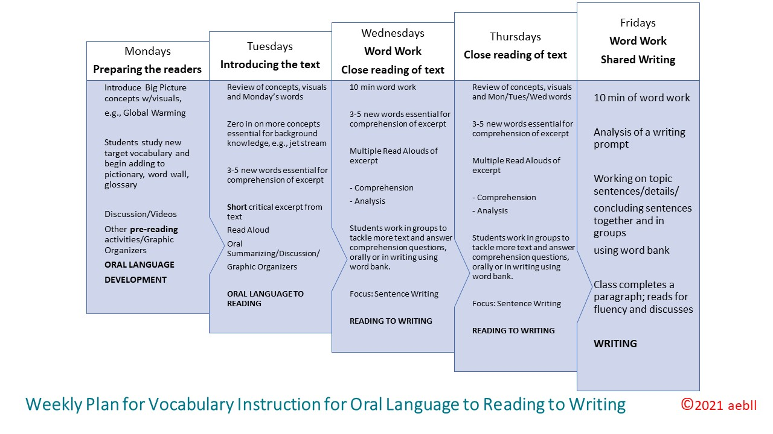

Blank Weekly Template

Monday  Preparing the Readers | Tuesday  Introducing the Text | Wednesday  Close Reading & Sentence Writing | ThursdayClose Reading & Sentence Writing | Friday  Shared Writing
 |  | 10 min word work |  | 10 min word work

